Vector Based Drawing Application

1-Mostafa Nabil Mohamed

2-Reham Mohamed Naguib

UML:

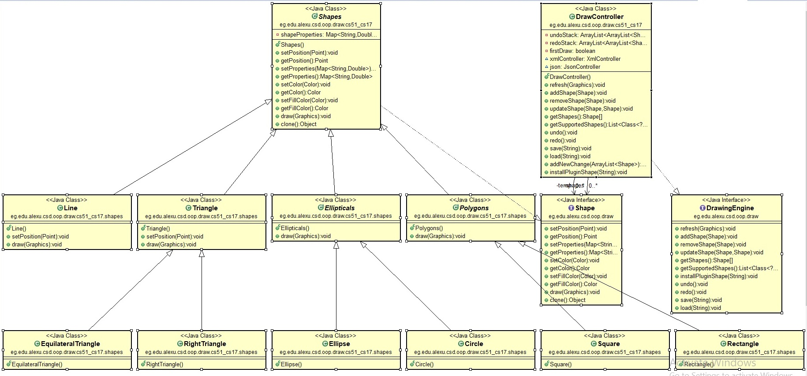

## Design description:

While designing out application we’ve noticed some common properties between certain shapes so we created parent classes that can be extended in all common-properties shapes such as

Polygons: which is the parent class for both Square and Rectangle classes as they both have 2 dimensions that are only equal in the Square case.

Ellipticals: the parent class for both the Circle and the Ellipse as they both can be drawn with 2 radiuses that are equal in the Circle case.

Triangle:the parent class for the Right angle triangle and the Equilateral triangle.

## User Manual:

### 1-Draw:

To draw a certain shape, one must select the shape icon from the toolbar and then click on the drawing area on the screen and draw the shape by dragging the cursor.

## 2-Select:

To select any shape on the screen, one must select the select icon from the toolbar and then click inside the required shape for it to be selected. A red outline will then appear on the shape to show that this shape was selected.

## 3-Move:

To move any shape on the screen, one must select the required shape first and then click on the move icon from the toolbar and then move the selected shape by dragging it from one point to another.

## 4-Resize:

To resize any shape on the screen, one must select the required shape first and then click on the resize icon from the toolbar and then resize the selected shape by dragging it’s edge.

## 5-Copy:

To copy any shape on the screen, one must select the required shape first and then click on the copy icon from the toolbar and then click on the point when the copied shape should be.

## 6-Color:

To change any shape color on the screen, one must select the required shape first and then click on the border color icon from the toolbar in order to change the outline color of the shape or click on the fill color icon from the toolbar in order to change the fill color of the selected shape.

## 7-Save:

In order to save the current page, one should click the save icon on the top and select the destination of the saved file and name it with either .json extension or .xml extension.

## 8-Load:

In order to load a previously saved page, one should click on the load icon on the top and select the required json or xml file.

## 9-Undo:

To undo any step, one should click on the undo icon on top of the drawing screen (valid up to 20 undos).

## 10-Redo:

To redo any step, one should click on the redo icon on top of the drawing screen (valid up to 20 redos).

## ScreenShoots:

